Numele _________________ Data___________
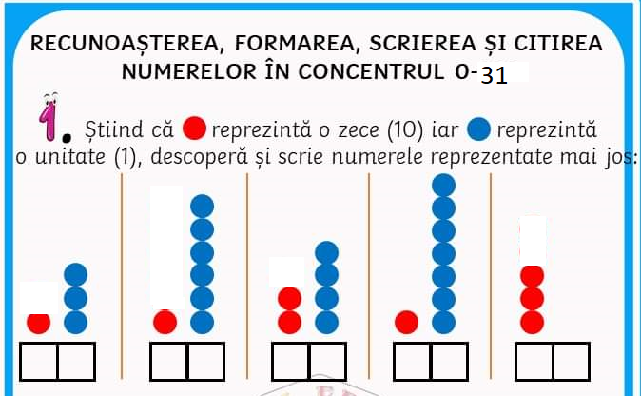
Numele______________________ Data_______________

